Project: Woodson Park Academy & YMCA-ELC
Week Ending: October 18th, 2019

THIS WEEK:
- Foundations wall pours
- Storm Line B completed
- Upper Detention pond completed
- Started lower level MEP
- Waterproofing at retaining wall
- Retaining wall backfill started

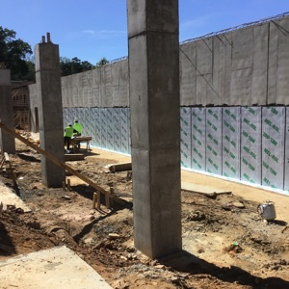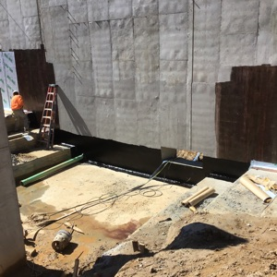

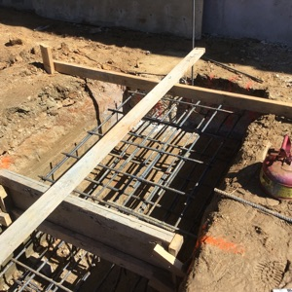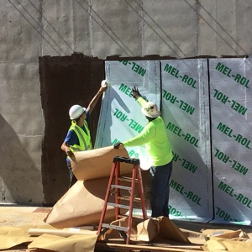

NEXT WEEK – October 21 thru October 25:
- Complete foundation wall
- Complete lower level piers
- Continue underslab MEP
- Start slab prep at kitchen area

PAYMENT STATUS:
- Gmp#1 $3,703,488.00
  - Paid to date amount $646,892.85
- GMP#2 $28,686,295.00
  - Paid to date amount $0.00

SCHEDULED DATE OF SUBSTANTIAL COMPLETION
- WPA – September 28, 2020
- YMCA-ELC - September 16, 2020

PREPARED BY:
- Matt Dauber, Carroll Daniel Construction Co.

